MathTutor Mastery Assignment
Error log
Stefan S
CSE 2140 2nd Language Programming
(MathTutor.java)
Describe the errors you’ve encountered while working on this assignment. What caused the error and how do you overcome the error?
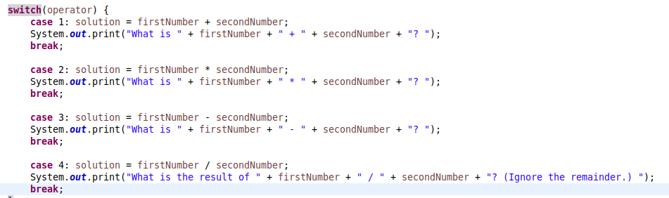
I forgot to add “break” to the end of each statement, so it would print every statement that appeared after the one I wanted, as well as the one I wanted.

Here I forgot to add unique max values and minimum values to determine the operator.

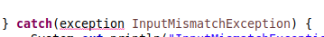

It took me a while to realize that I had to capitalize the E in Exception.

